MongoDb server Advanced 3

The following is the mongoimport command.

mongoimport --db database_name --collection collection_name ^

--authenticationDatabase admin --username <user> --password <password> ^

--file file_path

Now, execute the following command to import data from D:\MyData\employeesdata.json file to employees collection

D:\MyData> mongoimport --db test --collection employees --file employeesdata.json --jsonArray

The above command will import data into the employees collection in the test database. Note that --jsonArray indicates that the data in a file contains in an array.

## Import Data from CSV File

Consider that you have D:\employeesdata.csv file which you want to import into new employee collection. Execute the following command to import data from the CSV file.

D:\MyData> mongoimport --db test --collection employeesdata --type csv --file employees.csv --fields _id,firstName,lastName

The --fields option indicates the field names to be used for each column in the CSV file. If a file contains the header row that should be used as a field name then use --headerline option instead of --fields. The above command will insert all data into employees collection, as shown below.

test> db.employees.find()

[

{ _id: 2, firstName: 'bill', lastName: 'gates' },

{ _id: 1, firstName: 'steve', lastName: 'jobs' },

{ _id: 3, firstName: 'james', lastName: 'bond' }

]

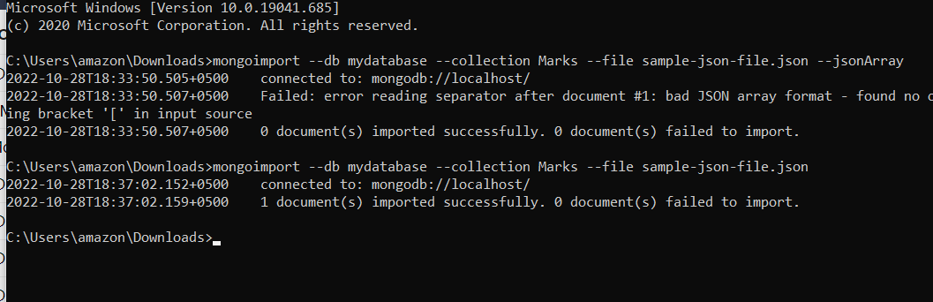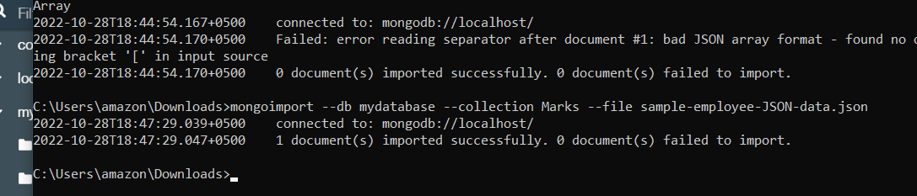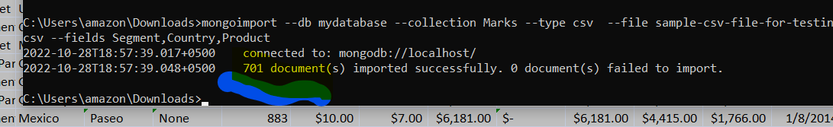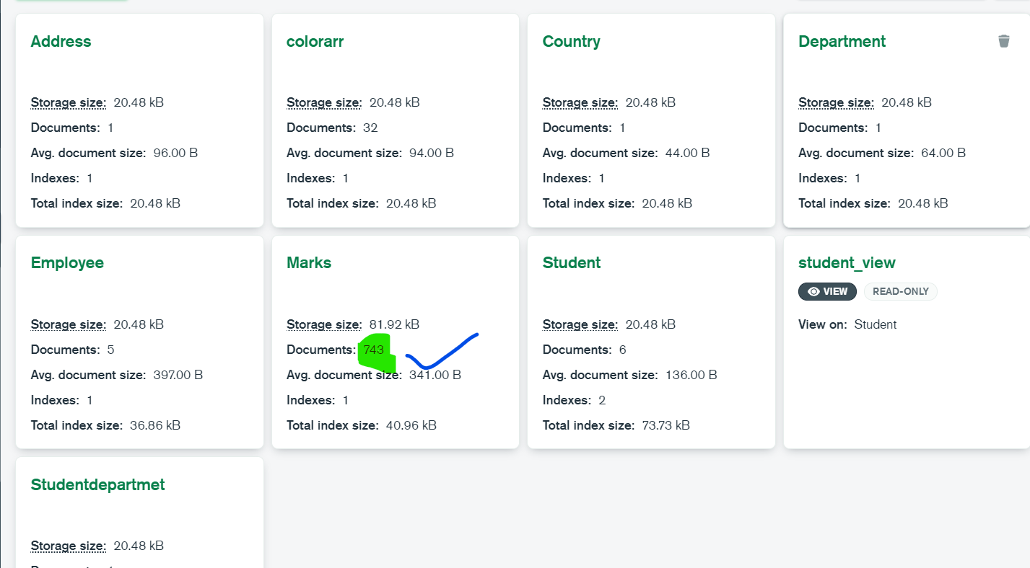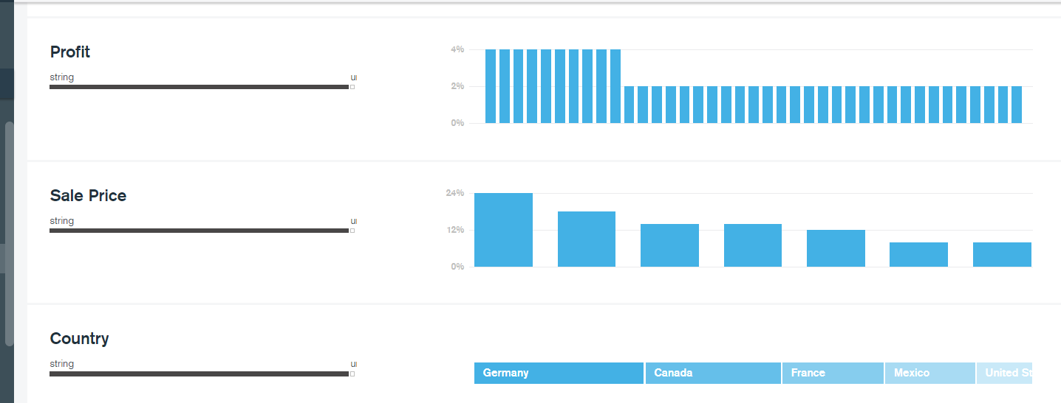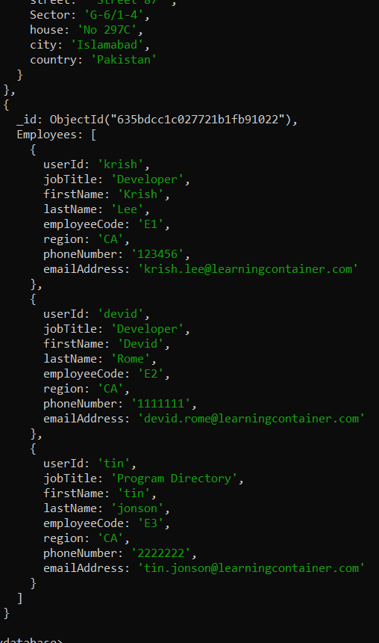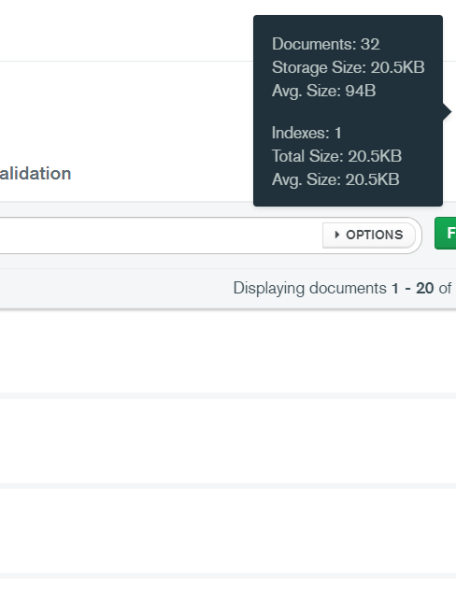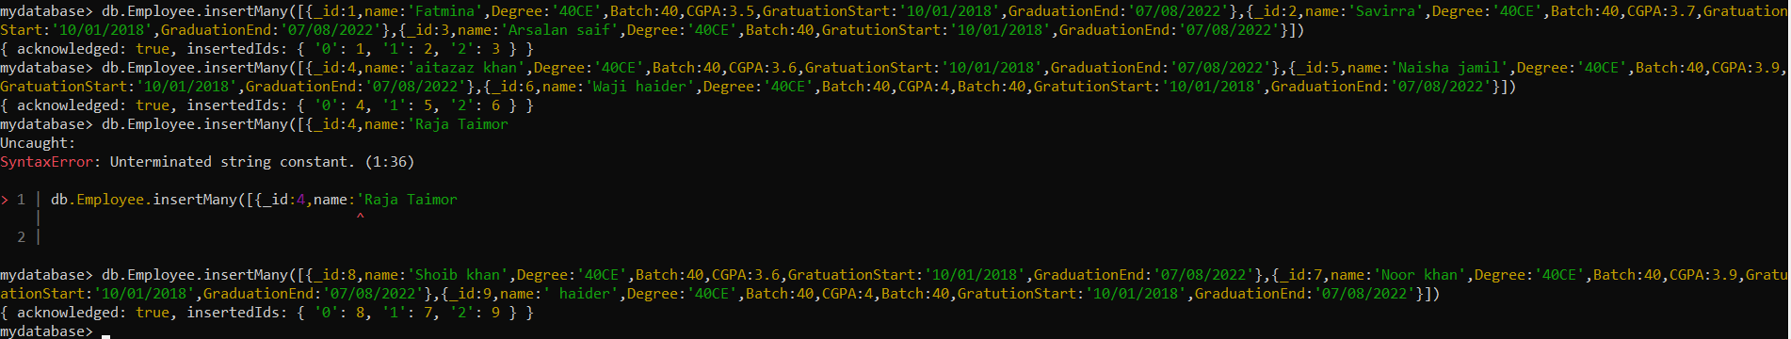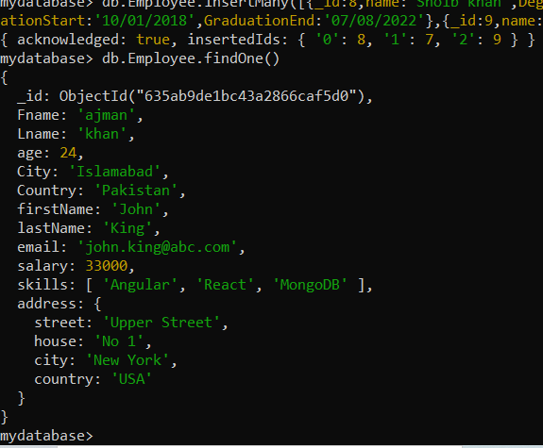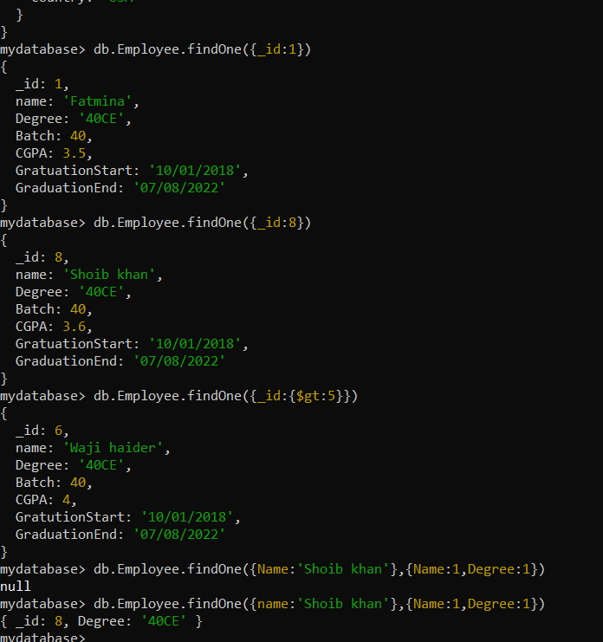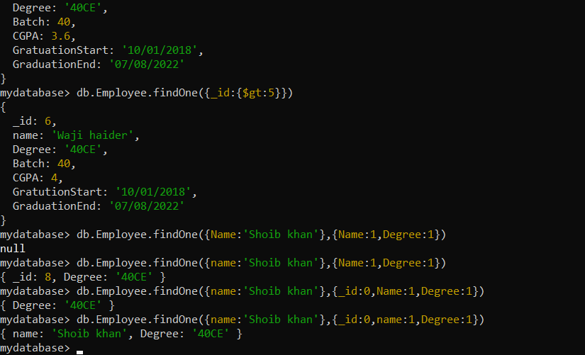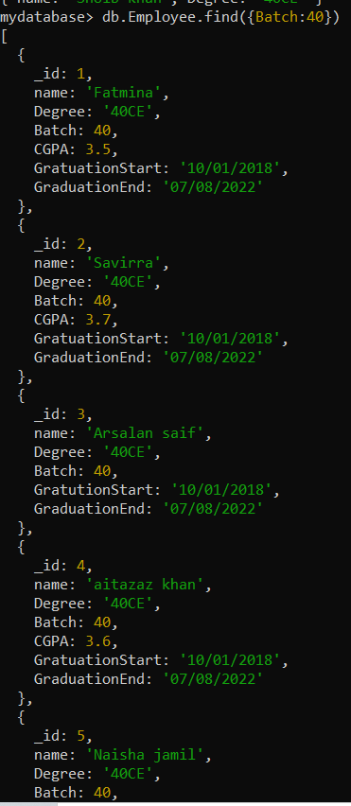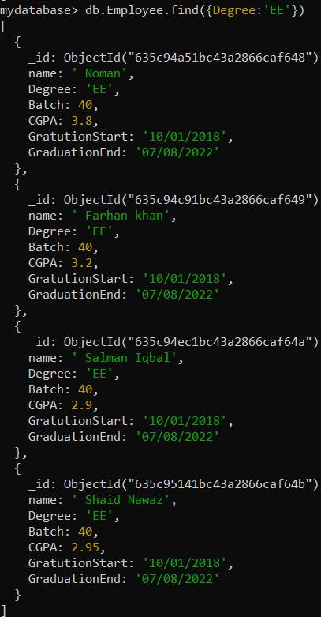

db.Employee.find({CGPA:{$gt:2.54,$lt:3.98}})

[

{

_id: 1,

name: 'Fatmina',

Degree: '40CE',

Batch: 40,

CGPA: 3.5,

GratuationStart: '10/01/2018',

GraduationEnd: '07/08/2022'

},

{

_id: 2,

name: 'Savirra',

Degree: '40CE',

Batch: 40,

CGPA: 3.7,

GratuationStart: '10/01/2018',

GraduationEnd: '07/08/2022'

},

{

_id: 4,

name: 'aitazaz khan',

Degree: '40CE',

Batch: 40,

CGPA: 3.6,

GratuationStart: '10/01/2018',

GraduationEnd: '07/08/2022'

},

{

_id: 5,

name: 'Naisha jamil',

Degree: '40CE',

Batch: 40,

CGPA: 3.9,

GratuationStart: '10/01/2018',

GraduationEnd: '07/08/2022'

},

{

_id: 8,

name: 'Shoib khan',

Degree: '40CE',

Batch: 40,

CGPA: 3.6,

GratuationStart: '10/01/2018',

GraduationEnd: '07/08/2022'

},

{

_id: 7,

name: 'Noor khan',

Degree: '40CE',

Batch: 40,

CGPA: 3.9,

GratuationStart: '10/01/2018',

GraduationEnd: '07/08/2022'

},

{

_id: ObjectId("635c94a51bc43a2866caf648"),

name: ' Noman',

Degree: 'EE',

Batch: 40,

CGPA: 3.8,

GratutionStart: '10/01/2018',

GraduationEnd: '07/08/2022'

},

{

_id: ObjectId("635c94c91bc43a2866caf649"),

name: ' Farhan khan',

Degree: 'EE',

Batch: 40,

CGPA: 3.2,

GratutionStart: '10/01/2018',

GraduationEnd: '07/08/2022'

},

{

_id: ObjectId("635c94ec1bc43a2866caf64a"),

name: ' Salman Iqbal',

Degree: 'EE',

Batch: 40,

CGPA: 2.9,

GratutionStart: '10/01/2018',

GraduationEnd: '07/08/2022'

},

{

_id: ObjectId("635c95141bc43a2866caf64b"),

name: ' Shaid Nawaz',

Degree: 'EE',

Batch: 40,

CGPA: 2.95,

GratutionStart: '10/01/2018',

GraduationEnd: '07/08/2022'

},

{

_id: ObjectId("635c95391bc43a2866caf64c"),

name: ' Zubair nawaz ',

Degree: 'ME',

Batch: 40,

CGPA: 2.95,

GratutionStart: '10/01/2018',

GraduationEnd: '07/08/2022'

},

{

_id: ObjectId("635c95651bc43a2866caf64d"),

name: 'Aftab khan ',

Degree: 'MC',

Batch: 40,

CGPA: 2.95,

GratutionStart: '10/01/2018',

GraduationEnd: '07/08/2022'

},

{

_id: ObjectId("635c95841bc43a2866caf64e"),

name: 'Irfan khan ',

Degree: 'ME',

Batch: 40,

CGPA: 3.5,

GratutionStart: '10/01/2018',

GraduationEnd: '07/08/2022'

},

{

_id: ObjectId("635c95a21bc43a2866caf64f"),

name: 'osman akram ',

Degree: 'MC',

Batch: 40,

CGPA: 2.95,

GratutionStart: '10/01/2018',

GraduationEnd: '07/08/2022'

},

{

_id: ObjectId("635c95c71bc43a2866caf650"),

name: 'Jibran khan ',

Degree: 'MC',

Batch: 40,

CGPA: 2.95,

GratutionStart: '10/01/2018',

GraduationEnd: '07/08/2022'

},

{

_id: ObjectId("635c96021bc43a2866caf651"),

name: 'Norakmal khan ',

Degree: 'ME',

Batch: 40,

CGPA: 2.95,

GratutionStart: '10/01/2018',

GraduationEnd: '07/08/2022'

},

{

_id: ObjectId("635c96951bc43a2866caf652"),

name: 'Ajab noor ',

Degree: 'MC',

Batch: 40,

CGPA: 3.5,

GratutionStart: '10/01/2018',

GraduationEnd: '07/08/2022'

}

]

mydatabase>

